Advance Cyber Security Serial No 09

Assignment 3

shreyyash

2020

March

Contents

1. Assignment 3: Basic Linux Dir Cmd 3
   1. Answer 1………………..…………………………. 3
   2. Answer 2………….…….…………………………. 4

List of figures

1.2.1 Figure 1: ls in new directory…………………………..…………… 3

1.2.3 Figure 2: Files before moving…….……………….……………….. 4

1.2.3 Figure 3: Files after moving…………………………………. …… 4

1.3.1 Figure 4: Unresponsive system after rm –rf /\*…………...………. 5

1.3.2 Figure 5: Kali machine IP in NAT mode…………………………… 5

1.3.3 Figure 6: Machine unresponsive after the cmd……………………… 5

CHAPTER3

Assignment 3: Basic Linux Dir Cmd

* 1. Introduction

The virtual machine as Task Machine created in virtual box. Folder with desired text files created using terminal.

* 1. Answer 1

1.2.1 ls cmd

This cmd lists the files and folders in the directory. Opening terminal in the newly created folder an running ls.

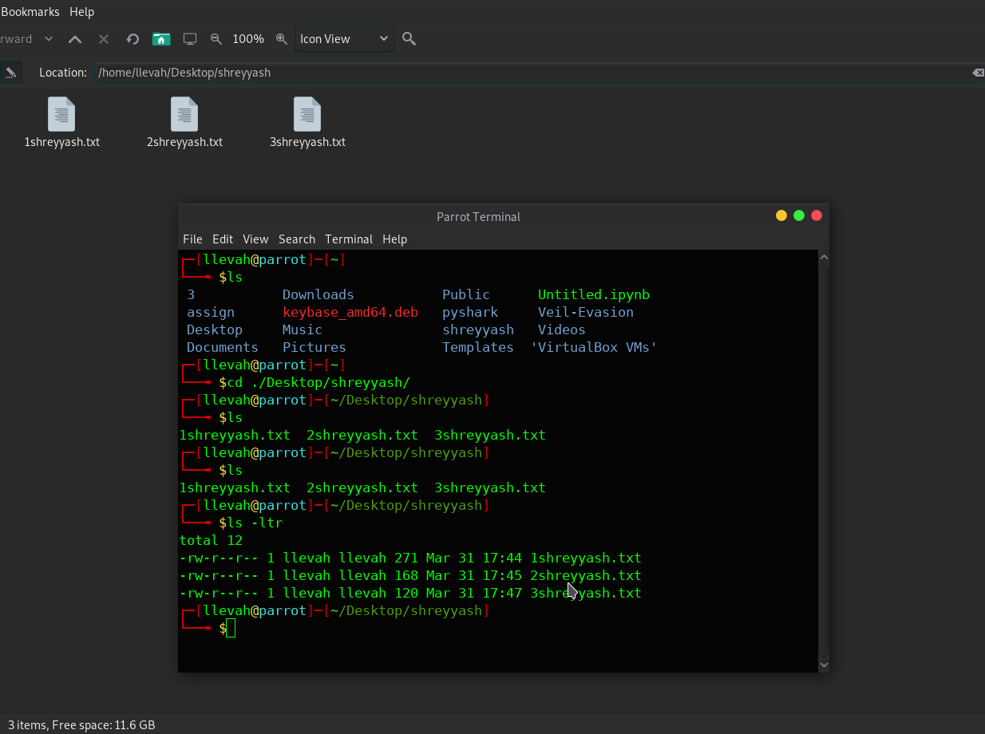

*Figure 1: ls in new directory*

1.2.2 ls –ltr cmd

This cmd gives out all the files and directories with more details such as date of last edit, permissions to the users etc.

1.2.3 Move files

The files were move using the *mv* cmd. The cmd used was

*mv \* /home/llevah/Public/destshreyyash*

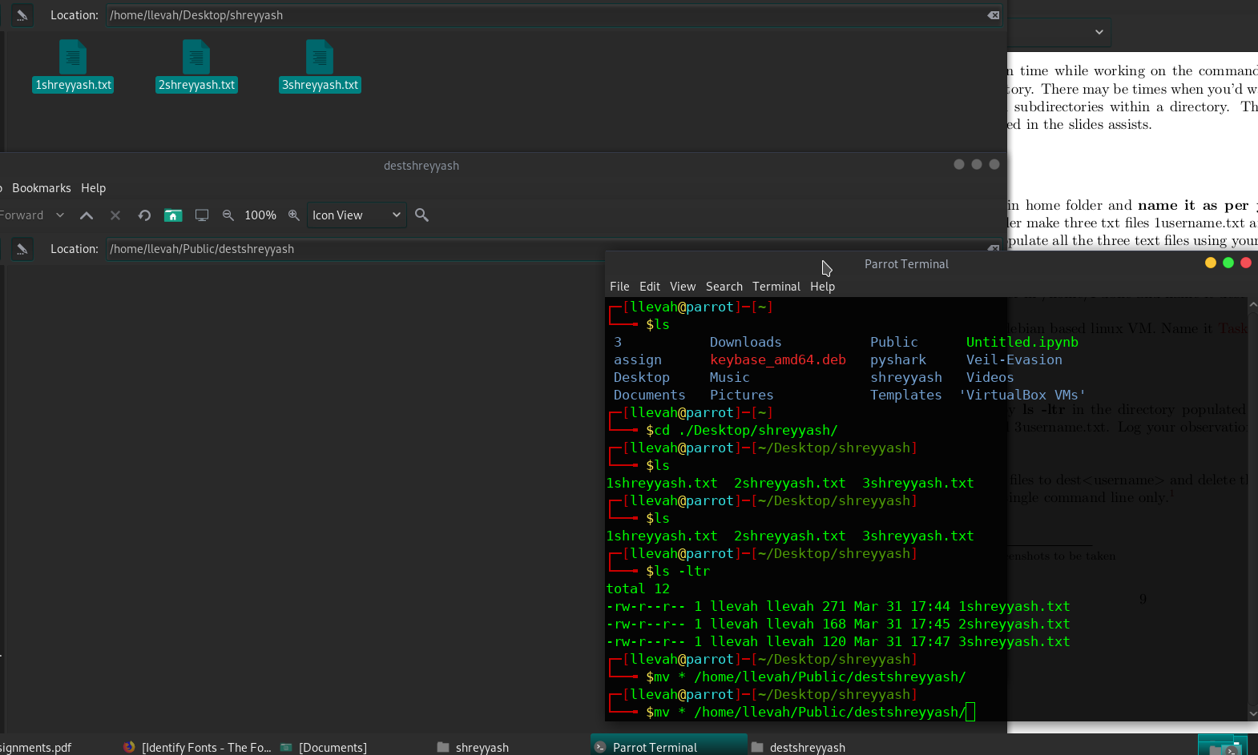

*Figure 2: Files before moving*

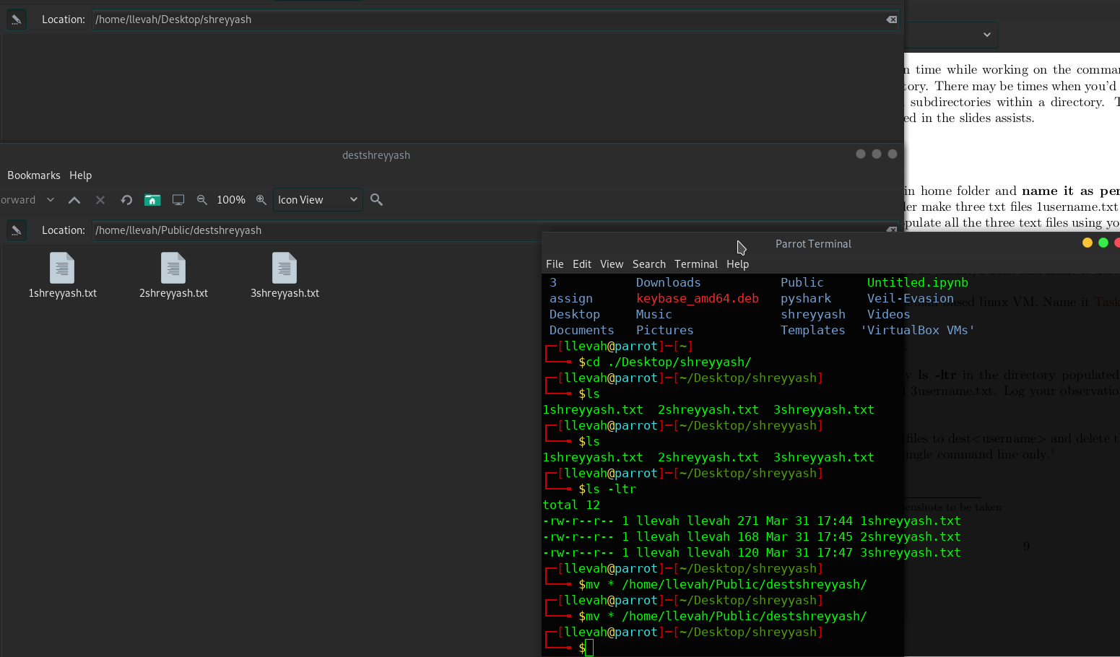

*Figure 3: Files after moving*

1.3 Answer 2

1.3.1 rm –rf /\*

This command can be broken down as follows

*rm – remove*

*-r - recursive*

*-f - force, no echo*

Running this cmd deleted the home directory files and rendered the system unusable.

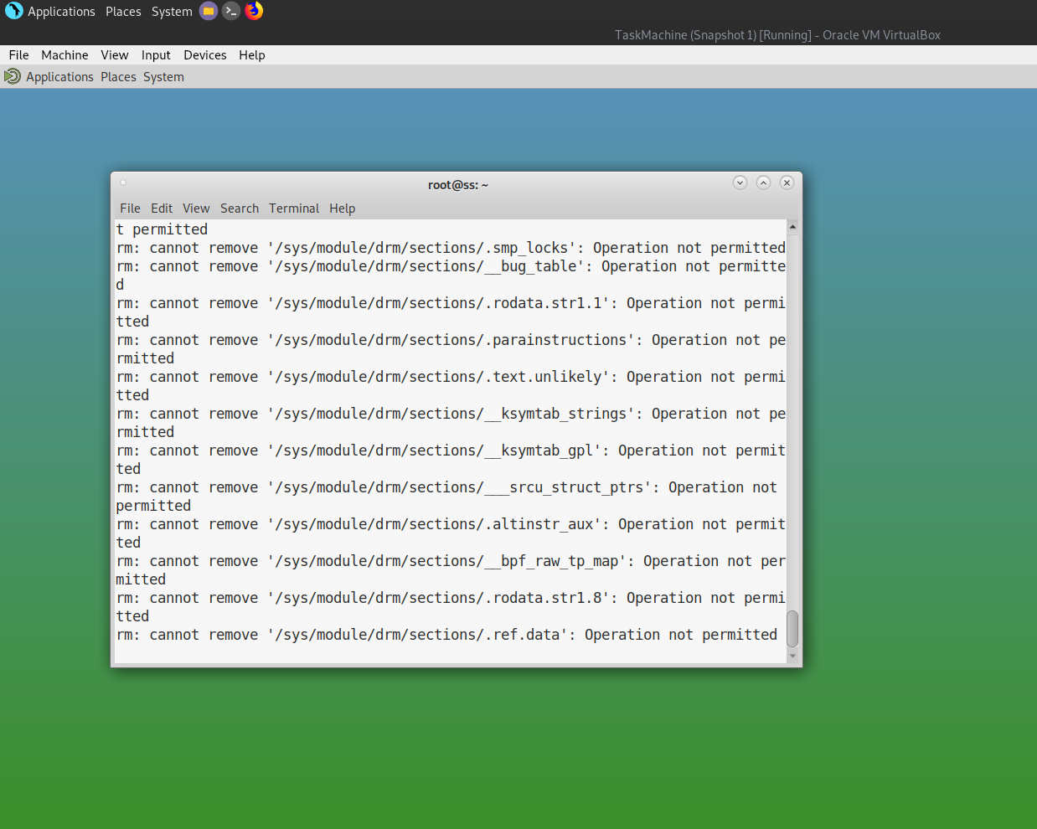

*Figure 4: Unresponsive system after rm –rf /\**

1.3.2 rm -rf --no-preserve-root /

This is a no holds barred variant of the previous cmd. Recovery after this cmd is near impossible.

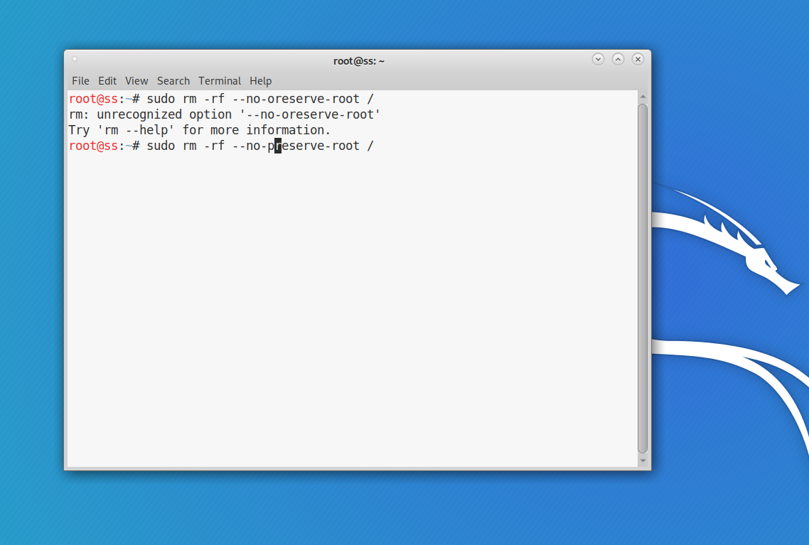

*Figure 5 : Machine unresponsive after the cmd*